Assignment #2

NES 595, Fall 2018, Dr. Ahmad T. Al-Hammouri

**Due date: Tuesday 16/10/2018 at 11:55pm.**

Student Names & IDs: Group #: .

**Objectives:**

* To explore and *master* the UNIX traditional and special permissions.

**Part I. Traditional UNIX permissions:**

1. As a regular user with regular permissions (i.e., no sudo), create a subdirectory, temp, inside your home directory. Then, create a file, a.txt (e.g., with touch), **inside** temp.

**Question 1.** What are the commands? *Provide* *an appropriate screenshot of the commands and their effect.*

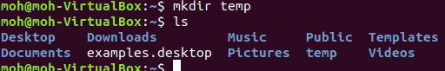

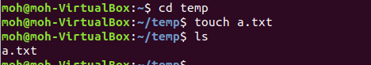

1. Change the permissions of a.txt to **grant** **full** access to it to **everybody** on the system. Then, change the permissions of temp to **prevent** **all** access to it to **all** accounts on the system.

**Question 2.** What are the commands? *Provide* *an appropriate screenshot of the commands and their effect.*

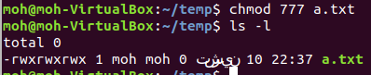





**Question 3.** Can you list the contents of temp (with ls -all)?

**No**



**Question 4.** Can you create another file, b.txt, inside temp?

No



**Question 5.** Can you change the current directory (with cd) into temp?

No



**Question 6.** Can you list the contents of a.txt (with less ./temp/a.txt)?

No

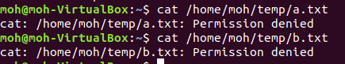

**Question 7.** What are the **MINIMUM** permissions to be given to temp to allow the owner to list its contents (i.e., display *complete* information about the contained file(s))? What is the command to achieve this? *Provide* *an appropriate screenshot showing the command and the effect, i.e., your test cases.*

*\*\*\*\*\*\*\*\*\*\*\*\*\*\*\*\*\*\*\*\*\*\*\*\*\*\*\*\*\*\*\*\*\*\*\*\*\*\*\*\*\*\*\*\*\*\*\*\*\*\*\*\*\*\*\*\*\*\*\*\*\*\*\*\**

*chmod 500 temp*



**Question 8.** What are the **MINIMUM** permissions to be given to temp to allow the owner to create another file, b.txt, inside it? What is the command to achieve this? *Provide* *an appropriate screenshot showing the command and the effect, i.e., your test cases.*



**Question 9.** What are the **MINIMUM** permissions to be given to temp to allow the owner to cd into it? What is the command to achieve this? *Provide* *an appropriate screenshot showing the command and the effect, i.e., your test cases.*



**Question 10.** What are the **MINIMUM** permissions to be given to temp to allow the owner to list the contents of a.txt (less ./temp/a.txt)? What is the command to achieve this? *Provide* *an appropriate screenshot showing the command and the effect, i.e., your test cases.*





**Question 11.** Suppose you have the following directory structure ~/dir1/dir2/dir3/dir4. Also, suppose that the permissions on each of dir1, dir3, and dir4 are rwxrwxrwx, and on dir2 are ---------. What kind of access, i.e., what are the operations, you can perform on dir4?

No operation can be performed on it.

1. Create a subdirectory, planetearth, inside the /home directory. (This requires administrative privileges, i.e., via sudo.)
2. Create **two** user accounts, adam, and eve.

**Question 12.** What are the commands? *Provide* *an appropriate screenshot showing the command and its effect.*

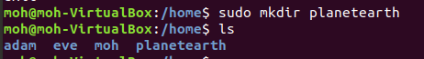

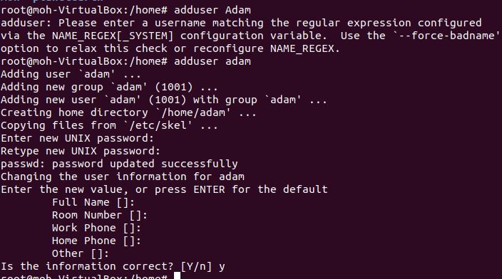

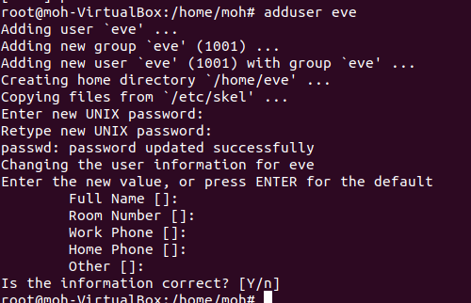

1. Configure the permissions, directory ownership, and group ownership such that
   * eve has **full** access on planetearth,
   * adam can **only list** the contents of planetearth, and
   * all other system accounts have **no** whatsoever access on planetearth.

**Question 13.** What are the commands? *Provide* *an appropriate screenshot showing the commands and their effect, i.e., your test cases.*

*First we can create new group*



Then we can add users adam,eve to that group

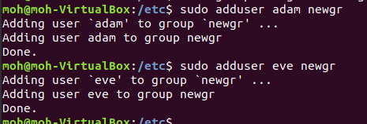

Then we can change the owner and group for directory “planet earth”,we give the ownership to eve and change the group to the new group that we’ve already created “newgr”





Then we can change the permissions of the directory “planetearth”







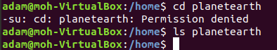

(**Hint**: *you can switch users without actually logging out and then logging in on the machine with a different user by utilizing the command* su -l newusername.)

**Part II. Special Permissions:**

1. As a regular user with regular permissions (i.e., no sudo), list the contents of the /etc/passwd file with the less command.

**Question 14.** Who is the owner of the less program/binary **file**? Which group does own it? What are the permissions of it? *Provide* *the appropriate screenshot.*

*the owner is “root”, in “root” group , permissions is 777*



**Question 15.** What are the UID and GID associated with the **running** less command (i.e., the process) above? What are the corresponding user name and group name? *Provide* *the appropriate screenshot.*

*Uid : 1000 , Gid: 1000*

*User name :moh , group name : moh*



(**Hint**: *on another terminal, issue the command* ps -A -o pid,cmd,user,group,uid,gid.)

1. As a regular user with regular permissions, list the contents of the /etc/shadow file with less command.

**Question 16.** What is the output? *Provide* *the appropriate screenshot.*



**Question 17.** Briefly explain why you are getting such output*. \*\*\*\*\*\*\*\*\*\*\*\*\*\**

*in the case of “shadow” file nothing is permitted to “others” , so I couldn’t show it by “less” command.*

1. Set the setuid bit on the less (keeping other permissions the same).

**Question 18.** What is the command? *Provide* *an appropriate screenshot showing the command and its effect.*



1. As a regular user with regular permissions, list the contents of the /etc/shadow file with less command.

**Question 19.** What is the output? *Provide* *an appropriate screenshot showing the command and its effect.*



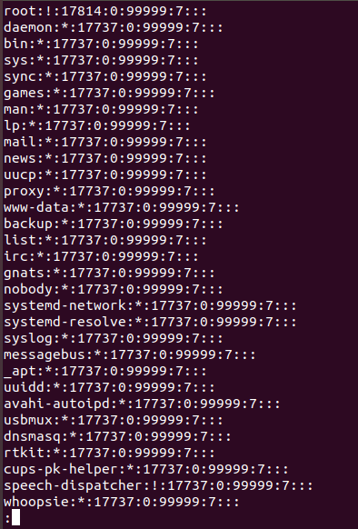

**Question 20.** What are the UID and GID associated with the **running** command (process) above? What are the corresponding user name and group name? *Provide* *the appropriate screenshot.*

*Uid :0 , gid :1000*

*User : root , group: moh*



1. Restore the original permissions on the less.

**Question 21.** What is the command? *Provide* *an appropriate screenshot showing the command and its effect.*





**Question 22.** Enumerate all binaries/programs on your machine that have the setuid bit set on them. What is the command? *Provide* *an appropriate screenshot showing the command and its output.*



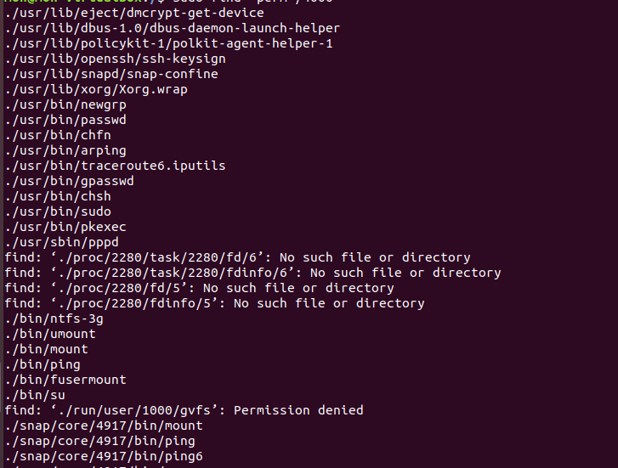

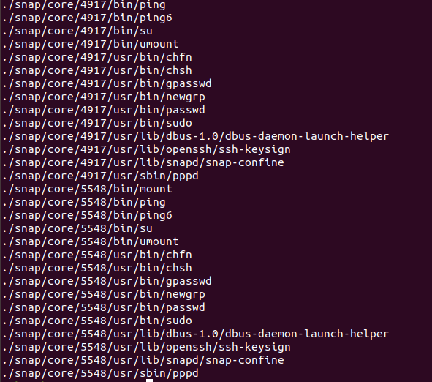

1. As a regular user with regular permissions, create two subdirectories inside your home directory, temp1 and temp2.
2. Create a group, programmers, and **add** your user name to programmers. Then, change **group owner** for **both** temp1 and temp2 to programmers.

**Question 23.** What are the commands? *Provide* *an appropriate screenshot showing the commands and their effect.*

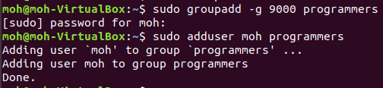



1. Set the setgid bit on temp2 **only** (keeping other permissions the same).

**Question 24.** What is the command? *Provide* *an appropriate screenshot showing the command and its effect.*





1. As a regular user with regular permissions, create a subdirectory inside temp1 and a subdirectory inside temp2. Also, create a file (e.g., with touch) inside temp1 and a file inside temp2.

**Question 25.** What are the commands? *Provide* *an appropriate screenshot showing the commands and their effect.*

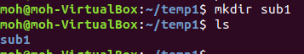





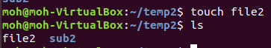

**Question 26.** Who is the owner of the subdirectory and file inside temp1? Which group does own them? What are the permissions of both? *Provide* *the appropriate screenshot.*

Owner :moh , group : moh



**Question 27.** Who is the owner of the subdirectory and file inside temp2? Which group does own them? What are the permissions of both? *Provide* *the appropriate screenshot.*

Owner :moh , group: programmers



1. After switching to user eve you created in Part I above, create a file, eve.txt, **inside** the /tmp directory. Also, after switching to user adam, create a file, adam.txt, **inside** the /tmp directory.





**Question 28.** What are the permissions of /tmp?



**Question 29.** Can eve delete adam.txt (with rm -f /tmp/adam.txt)? Can adam delete eve.txt?

No



1. **Unset** the **sticky** bit on /tmp while keeping other permissions the same.

**Question 30.** What is the command? *Provide* *an appropriate screenshot showing the command and its effect.*





**Question 31.** Can eve delete adam.txt (rm -f /tmp/adam.txt)? Can adam delete eve.txt?

Yes

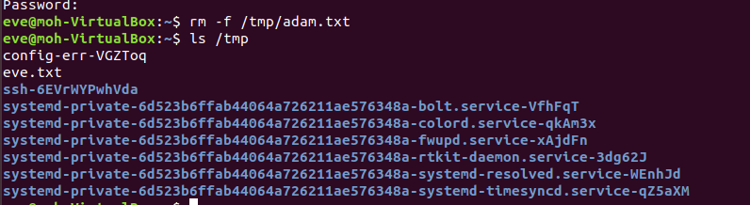

1. Restore the sticky bit on /tmp.

**Question 32.** What is the command? *Provide* *an appropriate screenshot showing the command and its effect.*





**Deliverables:**

Answer all questions (1–32) above, provide the required *appropriate* screenshots, and upload the file to the elearning via the provided link. Do **NOT** send it via e-mail or a message from within the elearning *even before the deadline* ***because it will be deleted tacitly***.